 University Of Engineering & Technology Peshawar

**Circuit and system I**

**Lab report # 1**

**Fall 2020**

**Submitted by: Ashfaq Ahmad**

**Section: B**

**Reg No: 19PWCSE1795**

**Semester: 2nd**

**Submitted to:**

**Dr. faiz ullah**

**Department Of Computer System Engineering**

1. **Objectives of lab:**

* **Define and explain voltage, resister, and current.**
* **Define and explain digital multimeter.**
* **Find the resistance current and voltage by using digital multimetr**
* **To know about the power supply.**
* **To know about the breadboard.**
* **To know about parallel and series circuit.**
* **To know about open and short circuit.**

**2. a) current:**

  the flow of electrical charge carriers like electrons with drift velocity is called electric current.

* The common symbol for current is the uppercase letter **I.**
* Physicists consider current to flow from relatively positive points to relatively negative points; this is called conventional current or Franklin current.
* Current flows from negative to positive points.
* The SI unit for measuring electric current is the ampere (A).
* **ONE AMPERE** *of current is defined as one coulomb of electrical charge* *moving past a unique point in a second*.

Mathematically,

**I=Q/t**

**b) Voltage**

the potential difference in charge between two points in an electrical field is called voltage.

* An example of direct **voltage** is the potential difference between the terminals of an electrochemical cell.
* Voltage, also called **electromotive** **force**.
* **It is denoted by V.**
* **Volt** is the electrical unit of voltage or potential difference.
* **One Volt** *is defined as energy consumption of one joule per electric charge of one coulomb.*

Mathematically;

V=IR

**c) Resistance;**

**Resistance** is a measure of the opposition to current flow in an electrical **circuit**.

* Ohms are named after Georg Simon Ohm (1784-1854), a German physicist who studied the relationship between voltage, current and **resistance**.
* **Resistance** is measured in ohms, symbolized by the Greek letter omega (Ω).
* **ONE OHM** *is that resistance offered by an object when 1 volt potential difference is applied across it and 1 Ampere of current passes through it.*

Mathematically R= V/I

**3. Digital multimeter:**

A **digital multimeter** is a test tool used to measure two or more electrical values—principally voltage (volts), current (amps) and resistance (ohms).

* It is a standard diagnostic tool for technicians in the electrical/electronic industries.
* A **miltimeter** or a multitester, also known as a **volt**/ohm **meter** or VOM,

**Steps for measuring resistance through multimeter.**

1. Turn off power to the circuit.
2. Select resistance Ω.
3. Plug the black test lead into the COM jack and the red test lead into the Ω jack.
4. Connect the probe tips across the component or portion of the circuit for which you want to determine the resistance.
5. View the reading and be sure to note the unit of measure, Ω, ΩK, MΩ, etc.

**Steps for measuring voltage.**

1. Select volts AC (V~), volts DC (V—), mvolts (V—) as desired
2. Plug the black test lead into the COM jack and the red test lead into the V jack
3. Touch the probe tips to the circuit across a load or power source as shown (parallel to the circuit to be tested)
4. View the reading being sure to note the unit of measure

**Steps for measuring current.**

1. Turn off the power to the circuit
2. Disconnect, cut or unsolder the circuit, creating a place where the meter probes can be inserted
3. Select amps AC (A~), or amps DC (A—) as desired
4. Plug the black test lead into the COM jack and the red test lead into 10 amp (10A) or 300 milliamp (300mA) jack depending on the expected value of the reading
5. Connect the probe tips to the circuit across the bread as shown so that all current will flow through the meter ( a series connection)
6. Turn the circuit power back on
7. View the reading being sure to note the unit of measure

**Circuit diagram:**

|  |
| --- |
| Image result for circuit diagram of multimeter |

|  |
| --- |
| Image result for multimeter |

1. **Power supply:**

A power supply is an electrical device that supplies electric power to a electrical load or circuit.

* The primary function of a power supply is to convert electric current from a source to the correct voltage, current, and frequency to power the load or circut.
* As a result, power supplies are sometimes referred to as [electric power converters](https://en.wikipedia.org/wiki/Electric_power_converter). Some power supplies are separate standalone pieces of equipment, while others are built into the load appliances that they power.

There are many types of power supply. Most are designed to convert high voltage AC mains electricity to a suitable low voltage supply for electronic circuits and other devices.

**Steps to provide voltage source to the circuit:**

* 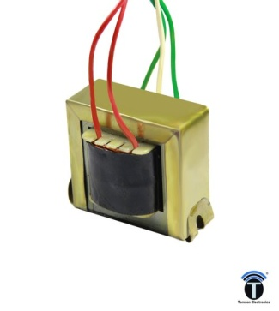[**Transformer**](https://electronicsclub.info/powersupplies.htm#transformer)**-** steps down high voltage AC mains to low voltage AC.
* **Bridge** [**Rectifier**](https://electronicsclub.info/powersupplies.htm#rectifier)**-** converts AC to DC, but the DC output is varying.

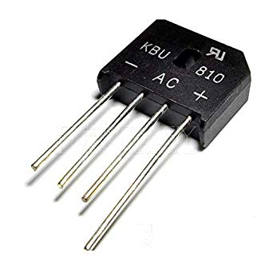

* 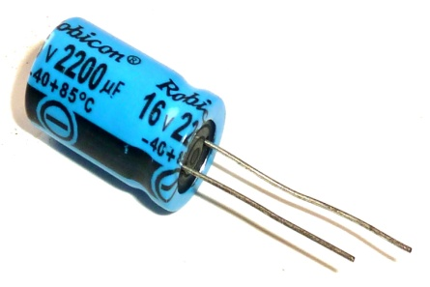[**Smoothing**](https://electronicsclub.info/powersupplies.htm#smoothing)**-** smooths the DC from varying greatly to a small ripple. Smoothing function is performed by large value electrulatic capacitor.
* 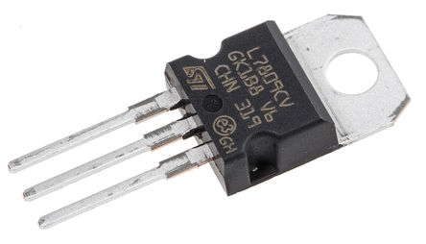[**Regulator**](https://electronicsclub.info/powersupplies.htm#regulator)**-** eliminates ripple by setting DC output to fixed voltage for the circuits.

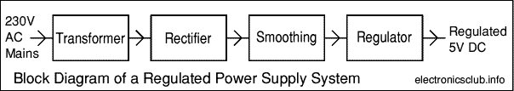

**Circuit diagram:**

|  |
| --- |
| Image result for dc power supply circuit diagram |

1. **Breadboard:**

A breadboard is a solderless device for temporary prototype with electronics and test circuit Most electronic components in electronic circuits can be interconnected by inserting their leads or terminals into the holes and then making connections through wires where appropriate.

* The breadboard has strips of metal underneath the board and connects the holes on the top of the board.
* Note that the top and bottom rows of holes are connected horizontally and split in the middle while the remaining holes are connected vertically.

**Diagram:**

|  |
| --- |
| http://wiring.org.co/learning/tutorials/breadboard/imgs/breadboard-02.jpg |

**Steps to design a series circuit:**

* Attach the battery pack to the power and ground rails of the breadboard.
* Connect the one terminal of first resister to next terminal of resister by using breadboard as shown below.
* Take a jumper from +ive rail to the to the one end of three combined resister.
* Take another jumper from -ive rail to the another end of three combined resister.
* The series circuit is complete given below.

|  |
| --- |
| **https://qph.fs.quoracdn.net/main-qimg-80cb18b15984268020d08cea629ae83bseries circuit** |

**Steps To Design A Parallel circuit:**

* Attach the battery pack to the power and ground rails of the breadboard.
* Now take three resister and connect the three terminals on one side through jumper on breadboard as shown below.
* Similarly also connect the three terminals on another side through jumper on breadboard as shown below.
* Now connect the one terminal of the battery to one side of the resisters another terminal to another side given below.
* Parallel circuit is complete.

**Diagram**

|  |
| --- |
| **Parallel circuit**  https://qph.fs.quoracdn.net/main-qimg-ddcc88b07f621f2a72b31a336d6a8b45 |

**Open circuit:**

An **open circuit** is one where the continuity has been broken by an interruption in the path for current to flow.

**DIAGRAM**

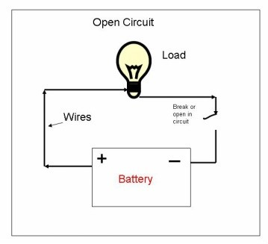

**Closed circuit:**

. A **closed circuit** is one that is complete, with good continuity throughout.

* A device designed to **open** or close a **circuit** under controlled conditions is called a switch.

**Diagram:**

|  |
| --- |
| **Image result for closed circuit diagramClosed circuit** |

**Percentage error:**

**Formula for finding percentage error is,**

**%age error =**

**OBSERVATIONS TABLE:**

|  |  |  |  |  |
| --- | --- | --- | --- | --- |
| **Actual voltage(v)** | **Measured voltage(v)** | **Resistance (Ω)** | **Current** | **% Error** |
| **5** | **5.05** | **9.8k** | **0.51mA** | **1%** |
| **15** | **14.9** | **101.8k** | **0.147mA** | **0.6%** |
| **15** | **15.1** | **111.9** | **0.13mA** | **0.6%** |
| **15** | **14.99** | **150k** | **0.000993mA** | **0.06%** |
| **-5** | **15.04** | **1.7k** | **8.85mA** | **0.2%** |

**THE END**